Exception Handling in Java

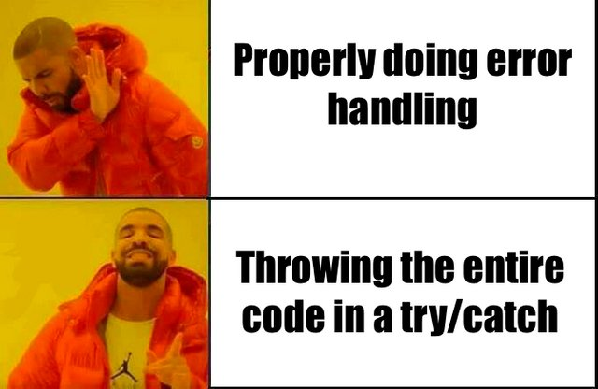

Which topic’s we will cover in this Article:

1. What is Exception?
2. What is Exception Handling?
3. Hierarchy of Exception classes(figure)?
4. Major reason’s why exception occurs?
5. Type’s of Exception’s?
6. Advantages of Exception Handling?
7. What is Throws and Throw?
8. Example’s of Exception.

***What is Exception?***

Exception is unwanted event, which occurs during the execution of program, that disrupt the normal flow of program.

We can handle and caught the exception’s by the program.

When exception occurs in method, it creates an object. And this object is called the “Exception Object”. This contains the information of exception like name, description.

***What is Exception Handling?***

In Java is one of the effective to handle the runtime errors, so that the regular flow of the application can be preserved.

Java Exception Handling is a mechanism to handle runtime errors such as ClassNotFoundException, IOException, SQLException, etc.

***Hierarchy of Exception classes(figure)?***

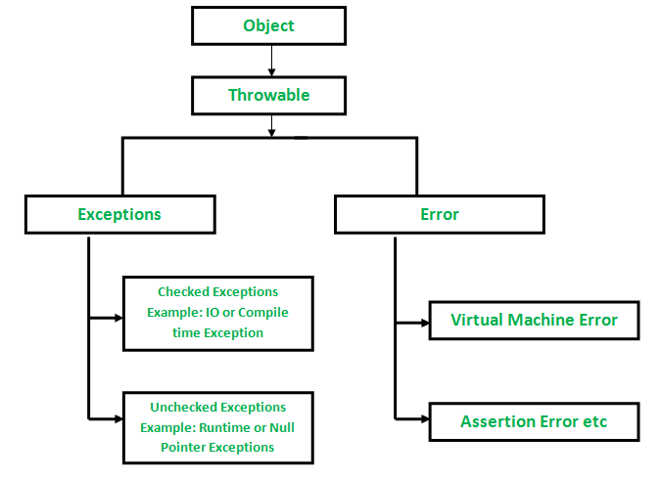

***Exception:*** Exception indicates conditions that a reasonable application might try to catch.

***Error:*** An Error indicates a serious problem that a reasonable application should not try to catch.

***Major reason’s why exception occurs?***

1. Invalid or Not Proper Input from User.
2. Device Failure.
3. Coding Error’s.
4. Opening an unavailable file.
5. Physical limitation’s.
6. Loss of network connection’s.

***Types of Exception’s?***

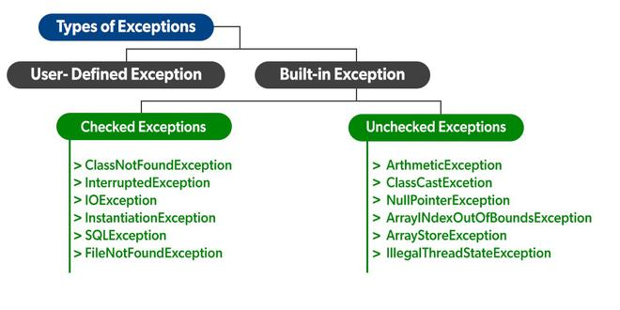

***Built-in Exception:*** this exception’s are available in java libraries. These are suitable to explain certain error situation’s.

***User-Defined Exception:*** some times built-in exceptions are not able to describe an certain situation, in such condition user can also create an exception and that’s called User-Defined Exception.

***Advantages of Java Exception Handling:***

1. To identify error types.
2. Meaningful error reporting.
3. Propagation of errors.
4. Easy identification of code error.
5. Provision to complete program execution.

***What is Throw and Throws:***

***Throw:*** The **throw** keyword is used inside a function. It is used when it is required to throw an Exception logically.

***Throws:*** The **throws** keyword is used in the function signature. It is used when the function has some statements that can lead to exceptions.

***Note:*** Coding Examples of Thro and Throws are Listed in Last Section See that for More Understanding.

***Example of Exception Handling:***

1]. NullPointerException

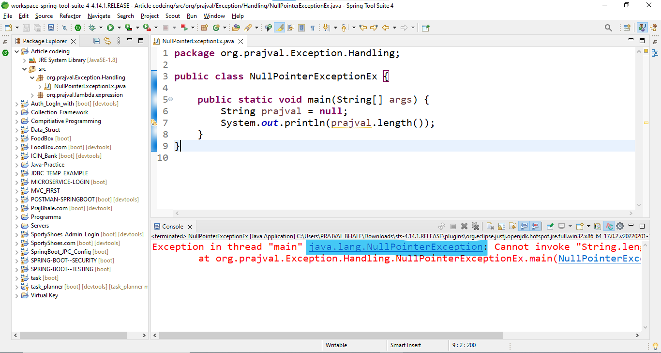

2]. ArrayOutOfBoundException:

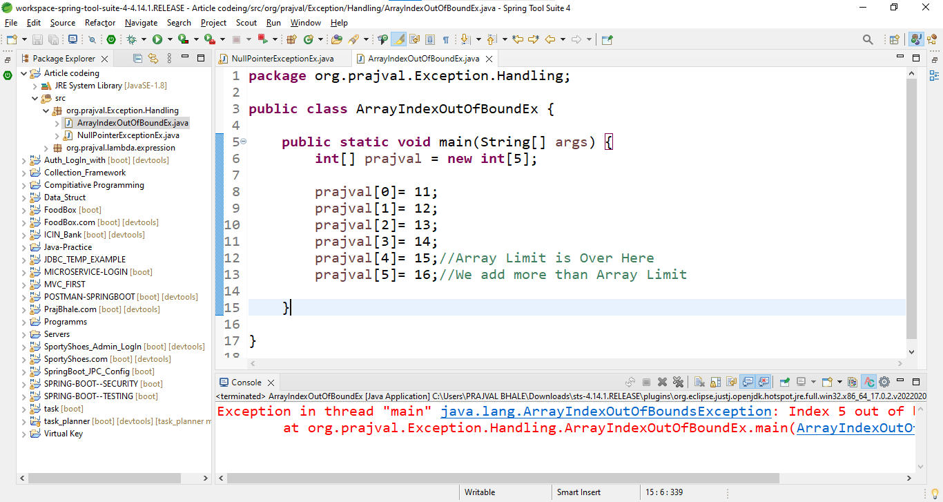

3]. Throw:

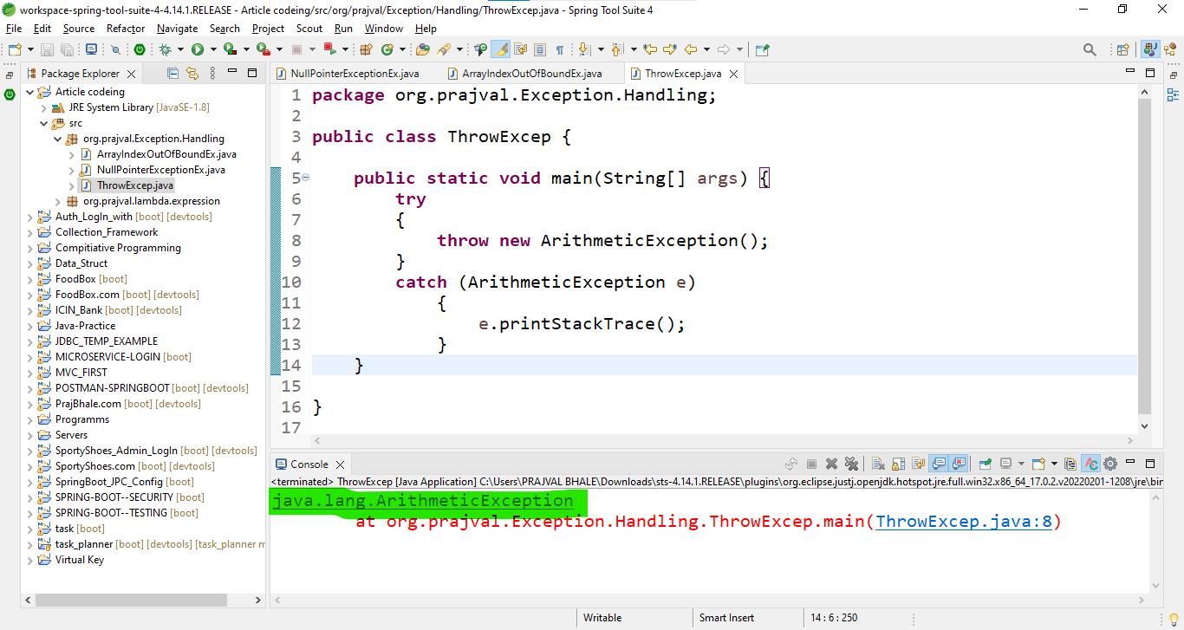

4]. Throws:

